INFOLABZ IT SERVICES PVT LTD

REACT | ASSIGNMENT 1 | 2 FEBRUARY 2024

1. US POPULATION API

API : <https://datausa.io/api/data?drilldowns=Nation&measures=Population>

1. PRINT TOTAL NUMBER OF MAUN KEYS
2. PRINT NAME OF MAIN KEYS
3. PRINT DATA AS PER BELOW TABLE FORMAT

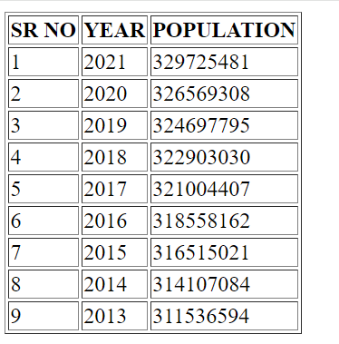

1. LOAD BELOW API AND SOLVE FOLLOWING QUESTIONS

API : <https://inshortsapi.vercel.app/news?category=sports>

1. PRINT TOTAL NUMBER OF MAIN KEYS
2. PRINT NAMES OF ALL MAIN KEYS
3. PRINT COUNT OF NEWS AVAILABLE IN THIS API
4. PRINT ALL NEWS USING FOR LOOP

OUTPUT SS :

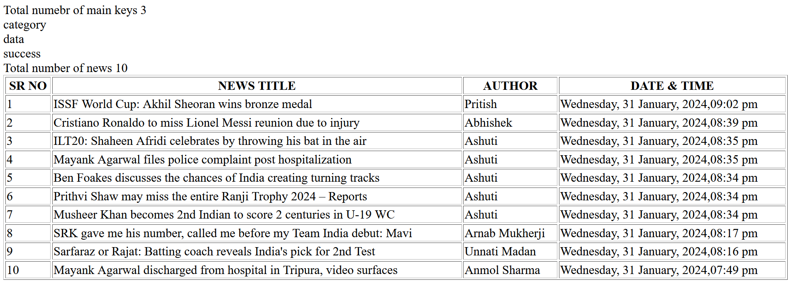

1. COPY DATA FROM BELOW OBJECT. AND SOLVE FOLLOWING QUESTIONS.

var mydata = [{"Message":"Number of pincode(s) found:4","Status":"Success","PostOffice":[{"Name":"Ashram Road","Description":null,"BranchType":"Sub Post Office","DeliveryStatus":"Non-Delivery","Circle":"Gujarat","District":"Ahmedabad","Division":"Ahmedabad City","Region":"Ahmedabad HQ","Block":"City Ahmedabad","State":"Gujarat","Country":"India","Pincode":"380009"},{"Name":"Darpan Society","Description":null,"BranchType":"Sub Post Office","DeliveryStatus":"Non-Delivery","Circle":"Gujarat","District":"Ahmedabad","Division":"Ahmedabad City","Region":"Ahmedabad HQ","Block":"City Taluka","State":"Gujarat","Country":"India","Pincode":"380009"},{"Name":"Gujarat University","Description":null,"BranchType":"Sub Post Office","DeliveryStatus":"Non-Delivery","Circle":"Gujarat","District":"Ahmedabad","Division":"Ahmedabad City","Region":"Ahmedabad HQ","Block":"Ahmadabad City","State":"Gujarat","Country":"India","Pincode":"380009"},{"Name":"Navrangpura","Description":null,"BranchType":"Head Post Office","DeliveryStatus":"Delivery","Circle":"Gujarat","District":"Ahmedabad","Division":"Ahmedabad City","Region":"Ahmedabad HQ","Block":"Ahmadabad City","State":"Gujarat","Country":"India","Pincode":"380009"}]}];

1. PRINT STATUS ( print Success )
2. PRINT Ashram Road
3. LOAD API AND PRINT IN TABLE FORMAT

API LINK : <https://api.postalpincode.in/pincode/380001>

SR NO | NAME OF AREA

OUTPUT SS :

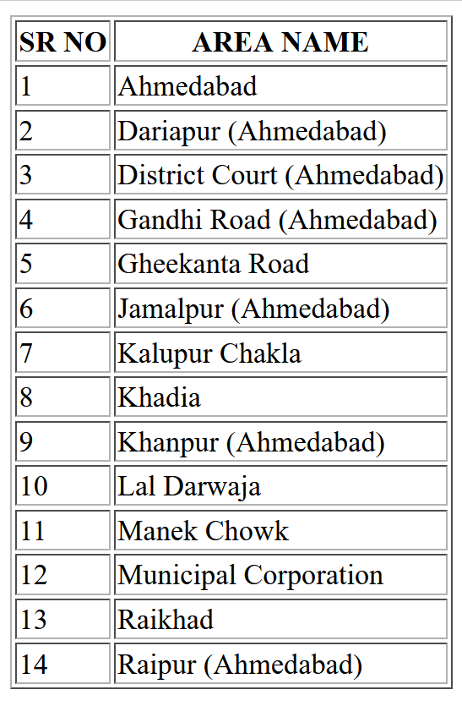

1. ALLOW USER TO INSERT PINCODE IN A FORM . PRINT ALL AREAS OF THAT PIN CODE. **( DIFFICULTY LEVEL HIGH )**

API LINK : https://api.postalpincode.in/pincode/{pincode}

OUTPUT SS :

